Spike: Task 13
Title: Composite & Component Patterns
Author: Mohamed Shafi Uzman Fassy, 102608927

Goals / deliverables:
The goal of this spike task is to extend our zorkish adventure game to create an immersive experience with the use of composite patterns and component patterns.

Besides this report, what else was created?
- Code files in see COS30031-2023-102608927\13 - Spike - Composite and Component Patterns\zorkish
- See modified .JSON file “world1” data structure.

Technologies, Tools, and Resources used:
List of information needed by someone trying to reproduce this work.
- Visual Studio 2022 Community Edition
- GitHub
- Task 12 Zorkish Code
Tasks undertaken:
- Set up task 12 zorkish project code into task 13 folder.
- Open it up Project Solution on Visual Studios.
- Modify .JSON file data structure to support entities and attributes.
- Modify Location to handle sublocations.
- Modify GameWorld to display available sublocations.
- Modify GoCommand to handle player movement into sublocations.
- Create Entities and Component Classes.
- Implement Component Attributes
- Create Extra Commands such as Open and Close Commands
- Compile Code and Test.

What we found out:

Composition Pattern
Since Composite Pattern involves creating objects in a tree structure to represent part-whole hierarchies, the objective was to enable clients to treat individual objects and composite objects uniformly. Therefore, I decided to implement sublocations within main locations by modifying our previous world1.json file from task 12.
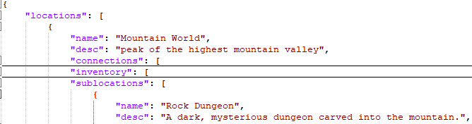
Figure 1: modified world1 Json file data structure.
I created a sublocation within Mountain World main location called Rock Dungeon in which players could move into only after they have moved into Mountain World giving it a name and description. This hierarchical relationship, where the main location contains sub-locations, exemplifies the Composite Pattern.
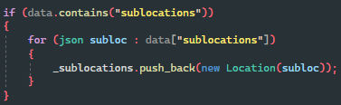
To do this, I modified the location class to check for the new sublocation we added to the game world so that when contrasting a location object from the JSON file data structure and if does exist, it recursively creates a location object for each sub location. This helps because we might want to add multiple sublocations down the line.
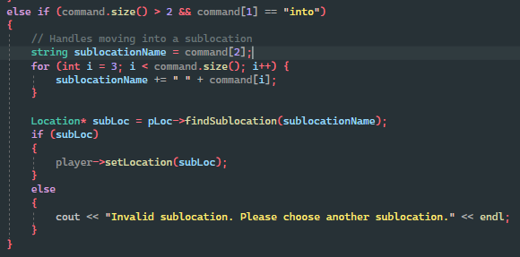
Once that was done, we had to make sure the player could interact with sublocations and to this we had to extend our existing command from the previous task called GoCommand that basically acted as a command to move players between locations by saying player types in “go into <sublocation_name>“ that would let the player know they moved into an available sublocation.
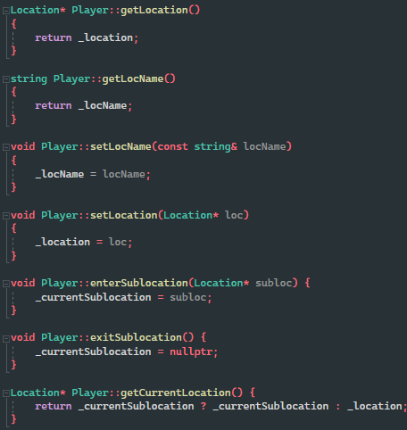
However, for the player to know where they are located, I had to modify the player class to store their current location using the getLocation() method when they originally moved into the main location when they selected their adventure world and then updating the getCurrentLocation() method to then see if they are entering a sublocation or existing the sublocation. Therefore, by clearly demonstrating movement between a main location and a sublocation to facilitate interactions with the composite structure.

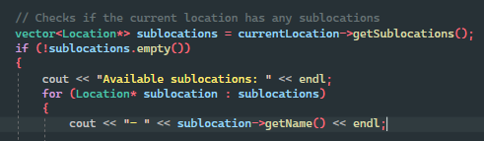
Finally, we check if the sublocation exists in the gameworld by checking the player’s current location has any sublocations within it and if so, then display the available sublocations for the player to chose from and go into.

Component Pattern
Since Component Pattern focuses on constructing objects from a system of behaviours instead of inheriting behaviour from a class hierarchy. Therefore, I modified the world1.json file which represents our game world once again and this time extended sublocations to manage entities with specific attributes and actions.
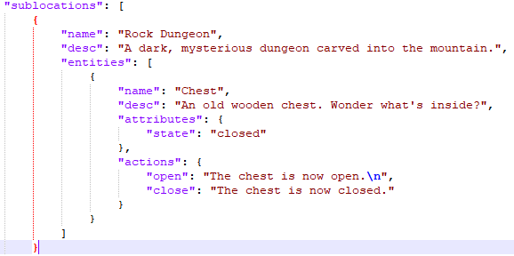
For demonstration purposes I implemented a chest entity that has an attribute state which by default is closed and using actions it can change state to open / close the chest so that the game environment feels interactive.

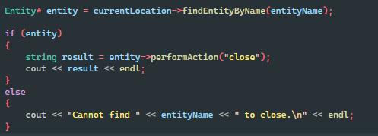
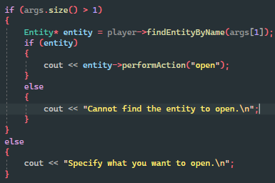
Furthermore, to make change the attribute state using actions I created to Commands called Open Command and Close Command so that when the player enters the command “open <entity name>” for example the chest that exists in the sublocation Rock Dungeon it will change the attribute state to open and display on the console that the chest was open and if the player enters the command “close <entity name>” again for example the chest which is now in open state, will change back to close state and display that the chest was closed.

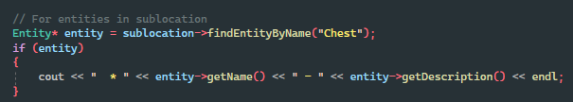
Finally, we again update the game world to find the chest entity to see if it exists within the current sublocation the player is currently located in and displays that a chest exists within the sublocation and for simplicity I hardcoded the find entity by name just to find an entity called chest.

Open issues/risks
Some of the issues I found out while testing out the game was that for some reason when I type in open chest or close chest it displays the chest attribute has changed which is intended but also displays the sublocation’s description.
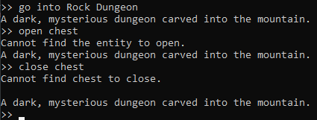
Also, another issue would be that I can not go back out of the sublocation to enter the main location and this could easily be fixed by implementing a go back command.

